(a)

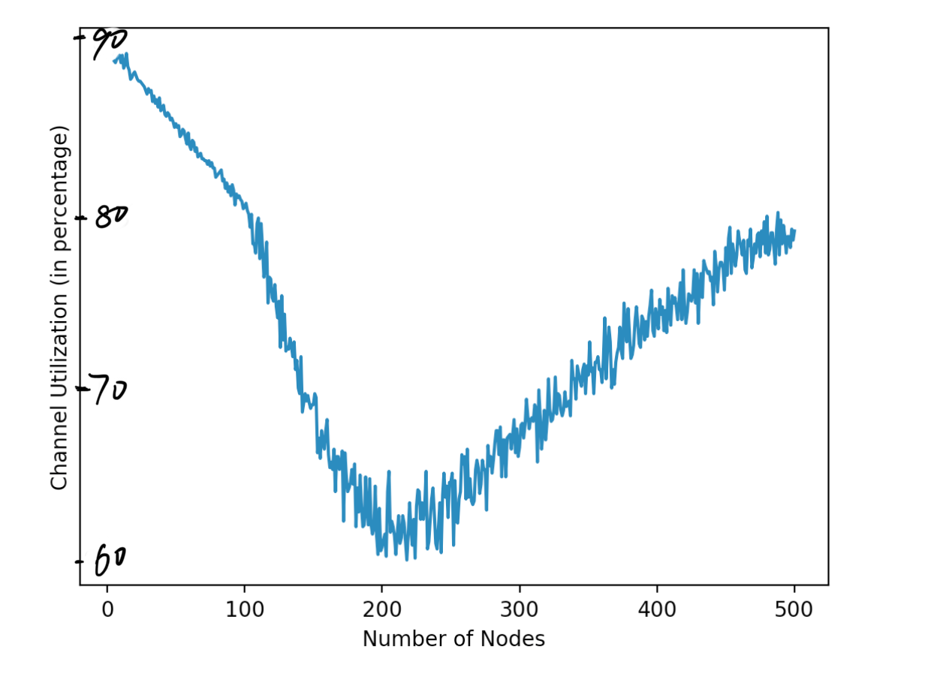

(b)

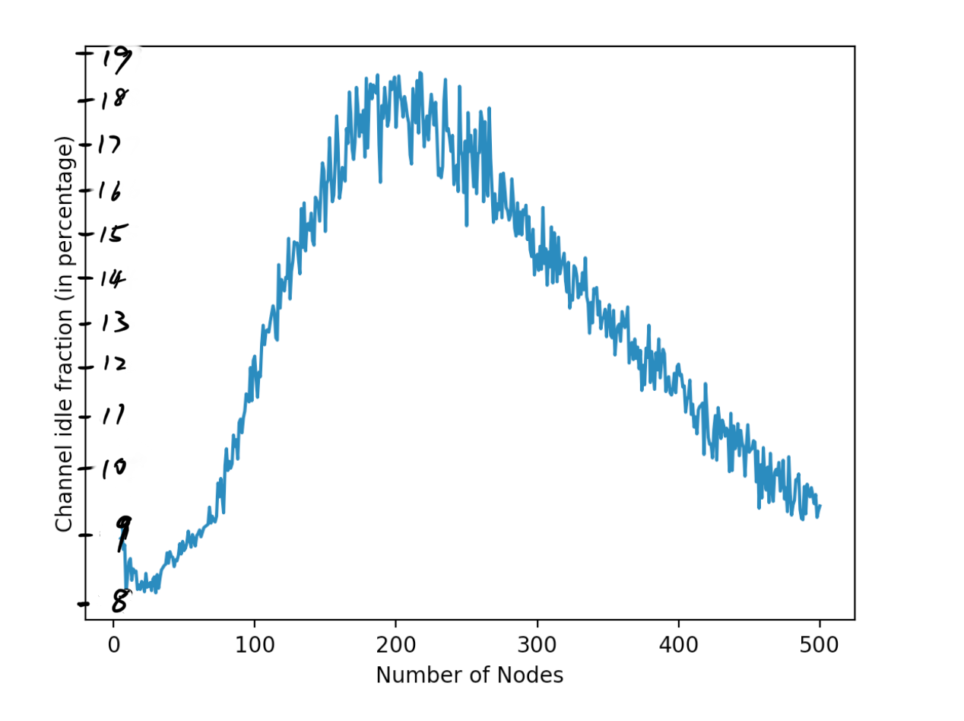

(c)

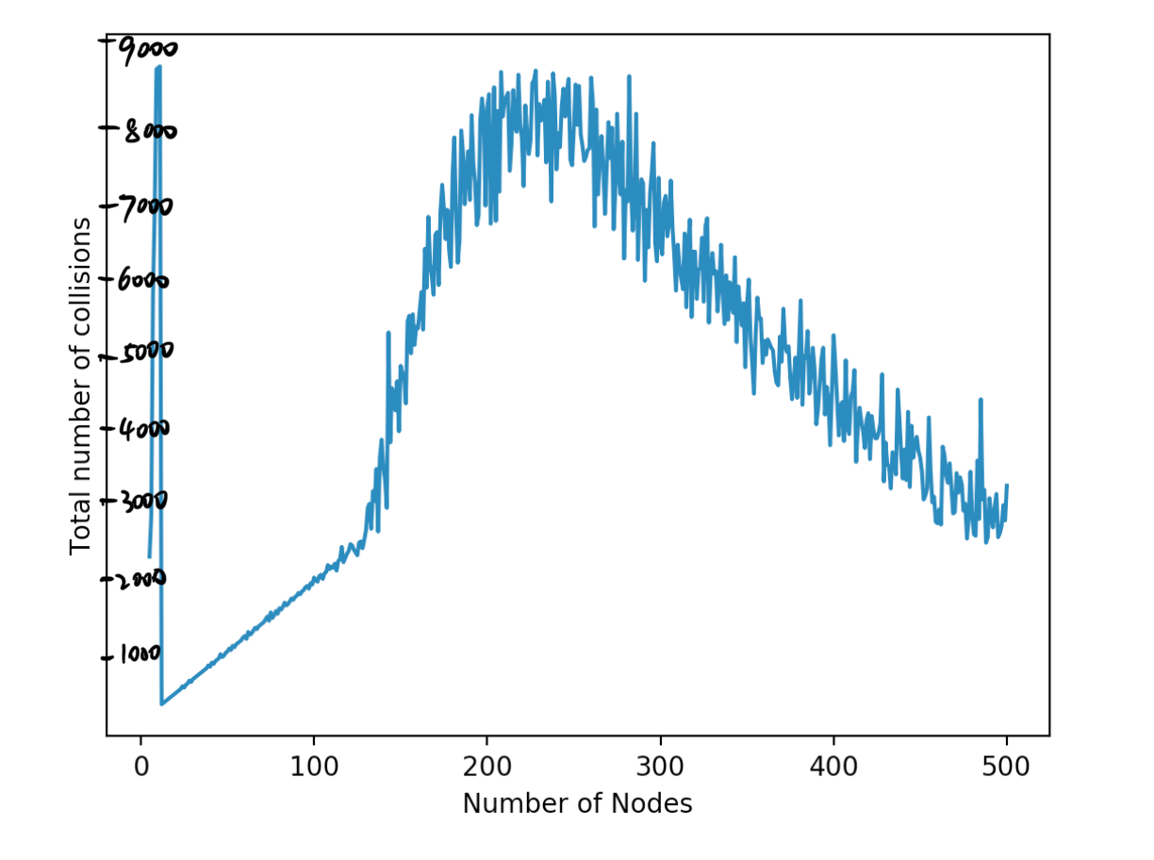

(d)

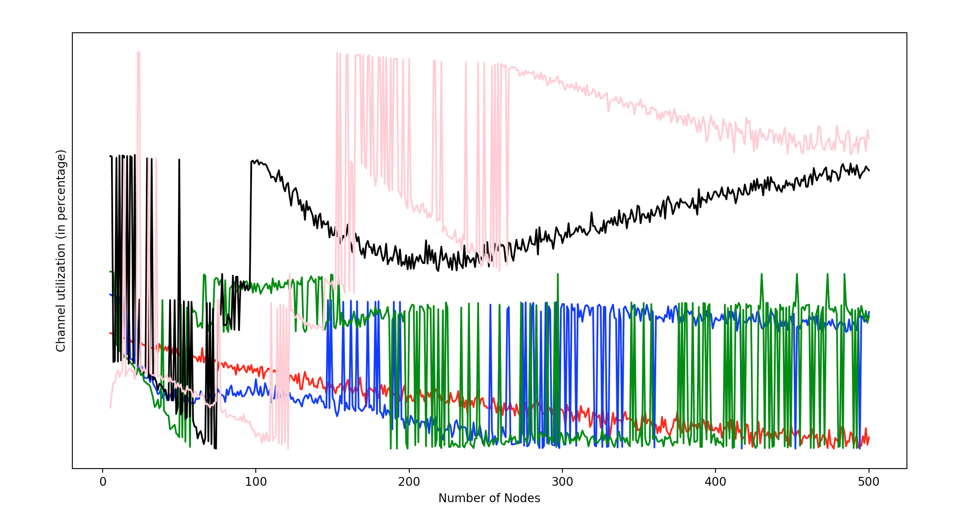

The red curve corresponds to initial value of R = 1.

The blue curve corresponds to initial value of R = 2.

The green curve corresponds to initial value of R = 4.

The black curve corresponds to initial value of R = 8.

The pink curve corresponds to initial value of R = 16.

(e)

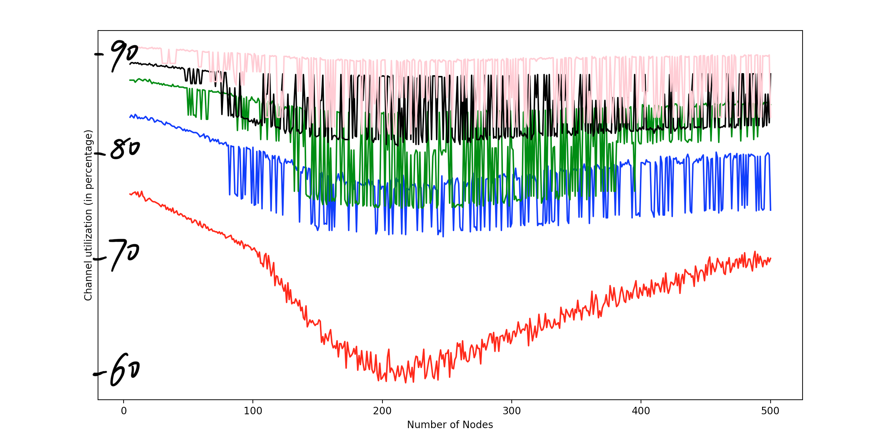

The red curve corresponds to initial value of L = 20.

The blue curve corresponds to initial value of L = 40.

The green curve corresponds to initial value of L = 60.

The black curve corresponds to initial value of L = 80.

The pink curve corresponds to initial value of L = 100.

(f)

For part (d):

Generally, channel utilization increases as the initial value of R increases.

Since R is the backoff range, the higher the backoff range, the less possible the collision would happen. Initially, channel utilization is higher for small value of initial R because initially the channel is not congested, meaning the number of collisions is not too big. Later since more nodes are introduced to the network, collision happens more often, R value will be much larger for larger initial R than for smaller initial R because R doubles. Therefore channel will have less congestion for larger R and channel utilization will be higher.

For part (e):

Channel utilization first decreases then increase as number of nodes increases.

The reason is that, initially, as more number of nodes is added to the network, the number of collision starts to build up, therefore the channel utilization decreases. After some time, the backoff value for collision avoidance become large, which decreases the collision in the network, therefore the channel utilization goes up.

Channel utilization increases as packet length L increases, for the same number of nodes.

The reason is that more time is used for sending packets rather than counting down the backoff number and handling node collisions.